February 2013

Dear Colleague:

Would you like to help shape the future of age studies in North America? If so, we invite you to be part of a working retreat this summer at Hiram College that aims to promote collaboration among age studies scholars from across the humanities, social sciences, and medical sciences.

This retreat—which arises out of the “Generate” grant initiative and the initial founding of NANAS, the North American Network of Aging Studies—will be housed at Hiram College this summer from July 25-28. The Generating NANAS retreat will have several key goals:
- To serve as the inaugural meeting of “Generate” project collaborators and advisors
- To gather a diverse group of scholars interested in advancing humanistic inquiry into aging and connecting practitioners of age studies with practitioners from multiple other disciplines;
- To review key moments and avenues of successful connection between diverse practitioners of age studies (particular scholarly efforts and publications, organizations/conferences, grants, etc.);
- To determine the needs, constituencies, and organizational possibilities for the newly formed North American Network of Aging Studies;
- To collaborate on finding revenue streams and organizational support for NANAS; and, in particular
- To begin the initial draft of a collaboratively proposed NIA R24 grant.

The motivation for the retreat arises from a few particular initiatives in which you have already played a key role. In 2010, the European Network of Aging Studies (ENAS) was formed, thanks in large part to a grant from the Netherlands Organization for Scientific Research, to bring together an interdisciplinary group of aging studies scholars that included strong representation from humanities scholars. Many of the North American participants of the ENAS’s landmark inaugural conference in Maastricht on October 6-9, 2011 expressed the desire for a North American equivalent of ENAS. In December of 2012, thirty age studies scholars from across the humanities, social sciences and medical sciences collaborated on submitting a grant to the NEH titled “Generate: Seeding the Future of North American Age Studies.” This grant, if funded, will provide opportunities for scholarly exchange and collaborative publications; even if not funded, the grant has provided valuable momentum for organizing our interests. In January of 2013 at a meeting sponsored by ENAS following the Modern Language Association Conference in Boston, the North American Network of Aging Studies (NANAS) was officially launched. You may read more about NANAS at www.agingstudies.org or you can visit it on Facebook at https://www.facebook.com/NorthAmericanNetworkOfAgingStudies). It is now time to solidify what this organization will do, where it will be housed, and how its activities will be funded.

This is where the summer retreat at Hiram comes in. Hiram’s Center for Literature and Medicine has a long tradition of bringing together emerging and established scholars and practitioners for intensive summer seminars and workshops that cross disciplinary and professional boundaries. While many of our summer seminars are open to the public, this summer’s working retreat will be by invitation only and will provide an intimate gathering focused on rich conversation and action-oriented planning. If you are interested in actively participating in the building of NANAS, we hope you will join us in July.

All members of the “Generate” grant project are being invited to the retreat. If you know of someone who is not part of the “Generate” grant but whom you think would be an excellent contributor to the retreat and to the planned NIA grant project, please pass that person’s name along to Erin Lamb at lambeg@hiram.edu or (330) 569-6139. Please know that we may not be able to invite all recommended participants due to space constraints, but we will be sure to include all of these names as we move forward with planning for NANAS.

As you are a “Generate” participant, Hiram’s Center for Literature and Medicine has committed to funding your lodging and meals for the retreat, though you will need to make and pay for your own travel arrangements. Please read the attached materials for more information about the logistics of costs, lodging, travel, etc. You may also find this information at http://www.hiram.edu/centers-of-distinction/litmed/summer-workshop.

We ask that all interested participants please register at https://hiram.wufoo.com/forms/generate-registration/ by April 30th, 2013. If you have questions or concerns, please contact Erin Lamb at lambeg@hiram.edu or (330) 569-6139.

Sincerely,
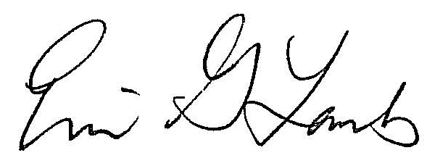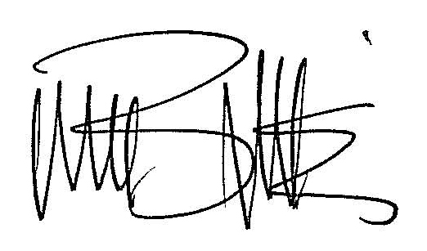

Erin Gentry Lamb Michael Blackie
Co-Director, Center for Literature and Medicine Co-Director, Center for Literature and Medicine
Assistant Professor, Biomedical Humanities Associate Professor, Biomedical Humanities
Hiram College Hiram College
lambeg@hiram.edu blackiemr@hiram.edu
330-569-6139 330-569-6113

p.s. We also invite you to mark your calendars for Hiram’s 2014 Summer Seminar on “Age and Ability” which will take place in July 2014. Open to a wide public constituency, this Center for Literature and Medicine seminar will focus on increasing dialogue among the aging studies and disability studies communities and exploring practical interventions for the purpose of decreasing ageism and ableism among healthcare practitioners and educators.

Generating NANAS
Program

All events will take place in the Alumni Heritage Room of Teachout-Price unless otherwise indicated.

Thursday, July 25th, 2013
- 6:00 – 9:00 p.m. Registration & opening reception: wine, beer, and hors d’oeuvres
East Hall entry foyer

Friday, July 26th, 2013
- 9:00 – 9:30 a.m. Continental Breakfast
- 9:30 – 12:00 p.m. Session I: Introductions. Small group planning sessions for the “Generate” project.
- Noon – 1:00 p.m. Lunch
- 1:00 – 3:30 p.m. Session II: Report back on planning sessions. Brainstorm NANAS: contributors, goals, challenges, milestones.
- 3:30 – 4:00 p.m. Break, with refreshments
- 4:00 – 5:00 p.m. Session III: Develop logical NANAS work groups and create group goals.
- 6:00 – 7:30 p.m. Dinner in Koritansky Hall
- 7:30 – 9:30 p.m. Optional evening cultural event/film screening

Saturday, July 27th, 2013
- 9:00 – 9:30 a.m. Continental Breakfast
- 9:30 – 12:00 p.m. Session I: NANAS work groups: how to achieve goals. Grant writing, part I.
- Noon – 1:00 p.m. Lunch
- 1:00 – 3:30 p.m. Session II: NANAS grant writing, part II.
- 3:30 – 4:00 p.m. Break (with refreshments)
- 4:00 – 5:00 p.m. Session III: NANAS wrap-up.
- 6:00 – 7:30 p.m. Dinner in Koritansky Hall
- 7:30 – 9:30 p.m. Optional evening cultural event/film screening

Sunday, July 28th, 2013
- 8:00 – 10:00 a.m. (optional) Continental Breakfast & Concluding Thoughts
- 10:00 a.m. – Noon NANAS PIs meeting

Generating NANAS
Logistics
For “Generate” grant participants:
Hiram’s Center for Literature and Medicine will cover all of the meals listed in the schedule and up to 3 nights of lodging in the College’s newest residence hall, East Hall. East Hall opened in 2008 and features 3-bedroom and 4-bedroom suites that have two bathrooms and a central living room, all air-conditioned. Each suite’s common area has a microwave, sink, refrigerator and cable internet connection. Wi-fi will be available across campus. Hiram College will provide each lodger with a linen packet containing a fitted sheet, flat sheet, pillow case, blanket, pillow, 2 bath towels, and a wash cloth. There may be rooms available at The Hiram Inn (http://hiraminn.thehiramcollege.net/). “Generate” participants may reserve the available rooms at the Hiram Inn at the cost of $40 per night.

For attendees who are not “Generate” grant participants:
Hiram’s Center for Literature and Medicine will subsidize costs as much as possible; the specific amount of the subsidy will depend on how many attendees are in this category. Participants’ basic expenses:
- $45/night for East Hall lodging; $85/night for Hiram Inn lodging (as available)
- $22 for opening reception
- $46 per day for all meals and snacks, July 26th and 27th
- $6 for breakfast , July 28th
Total: $255 per person for East Hall lodging; $375 for Hiram Inn lodging

All participants need to make and pay for their own travel arrangements to and from Hiram College.
Hiram College is located in the village of Hiram in Northeast Ohio and is less than an hour's drive from Cleveland, Akron, and Youngstown. If you are flying, the closest airports are Akron-Canton Regional Airport (CAK) and Cleveland-Hopkins International Airport (CLE). These airports are both approximately 45 minutes away from the campus. Shuttle services are available through both CAK and CLE, but shuttle costs tend to run $90 each way. We recommend that participants try to coordinate with one another to rent a car, and/or we may be able to provide limited group shuttles. We will be happy to facilitate this communication among registered participants.
Further details about the retreat, travel, accommodations, etc., will be provided to all registrants.
Registration Application: https://hiram.wufoo.com/forms/generate-registration/
Registration Deadline: April 30, 2013

